Epsom & Ewell F.C.
9
v
Ashford Town (Middx)
Saturday, 18th October 2014
For our League match this afternoon we welcome the players, officials and supporters of Ashford Town (Middlesex), along with today's match officials and of course our own regular supporters.

Today’s visitors are one of three that have dropped down from Step Four this season and are clearly having the greatest amount of success of those clubs, sitting in second place and breathing down the necks of the leaders Cove with a particularly impressive defensive record.

There was a time in the mid-nineties when our paths crossed quite a bit, but it has been ten years since we have hosted them. Our last meeting was quite a prestigious occasion as it was a Surrey Senior Cup Semi-Final back in March of 2009, with Ashford going on to win the Cup that season.

This of course led to the rather unusual situation of a club with Middlesex in its title winning the Surrey Senior Cup, and it has to be said that with the demise and reformation of the Kent based Ashford Town, now plying their trade as Ashford United, you could argue that our opponents today no longer require the geographical suffix!

We met Knaphill here on Tuesday in the League Cup and defeated them 2-1, although the scoreline was a lot closer than it should have been. We are making plenty of chances but need to take a greater number or we will face more nervy finishes against teams that we should be finishing off earlier. Anyway, we made it through and now travel to Frimley Green in the last 16 after they defeated Spelthorne Sports, also last Tuesday after extra time.

Coming up this Saturday we actually have an away match; the first since our trip to Spelthorne Sports on 27th September. It is an equally tough one as we face our good friends Camberley Town for the 83rd time in our history, which for those who don’t know, is the most times that we have played any club. #loveastat!

They are playing well and when you throw this game in before it, a home game with old rivals Chertsey Town and trips to Lingfield, Cove and Molesey after that, it is fair to say that we have now entered a pivotal and very difficult part of the season.

Please note that due to a Ryman League fixture rearrangement, we are no longer able to host Spelthorne Sports on 11th November. A new date for this match will be advised shortly.

Finally, we are still looking for player, match and match ball sponsors. We also have replica shirts available at £25. Please let me or any Committee Member know if you are interested.

Please help your club. We, Glyn and the boys value your support.

Enjoy the game!

Rich (Richard.c.lambert@gmail.com) on Twitter @EEFCOfficial

Cover photo this week by Gemma Jarman

Sam Robinson’s twenty-five yarder into the top corner
sets us on our way against Knaphill on Tuesday

Cherry Red Records
Combined Counties League
Premier Division Table 2014/15
inc 15th October 2014 | P | W | D | L | F | A | Pts | GD | H | A
Cove | 13 | 11 | 2 | 0 | 31 | 14 | 35 | +17 | 7/3 | 15/11
Ashford Town (Mx) | 12 | 10 | 1 | 1 | 32 | 7 | 31 | +25 | 18/10 | 10/1
Molesey | 11 | 9 | 0 | 2 | 40 | 11 | 27 | +29 | 22/11 | 28/2
Camberley Town | 13 | 7 | 3 | 3 | 26 | 10 | 24 | +16 | 7/2 | 25/10
Windsor | 11 | 7 | 2 | 2 | 28 | 12 | 23 | +16 | 3/1 | 11/4
Spelthorne Sports | 11 | 7 | 2 | 2 | 20 | 13 | 23 | +7 | 11/11 | 3-0
Epsom & Ewell | 13 | 6 | 2 | 5 | 24 | 17 | 20 | +7 | X | X
Colliers Wood United | 13 | 6 | 2 | 5 | 23 | 21 | 20 | +2 | 4/4 | 2-3
Mole Valley SCR | 12 | 4 | 4 | 4 | 24 | 23 | 16 | +1 | 1-0 | 18/11
Hartley Wintney | 9 | 5 | 1 | 3 | 10 | 9 | 16 | +1 | 21/2 | 1-2
Frimley Green | 12 | 4 | 4 | 4 | 23 | 25 | 16 | -2 | 0-0 | 25/4
Bedfont Sports | 12 | 5 | 1 | 6 | 16 | 23 | 16 | -7 | 0-1 | 20/12
Raynes Park Vale | 11 | 4 | 3 | 4 | 13 | 16 | 15 | -4 | 0-1 | 27/12
Horley Town | 13 | 3 | 4 | 6 | 23 | 27 | 13 | -4 | 2-2 | 6/4
Chertsey Town | 13 | 4 | 1 | 8 | 18 | 30 | 13 | -12 | 28/10 | 14/3
Westfield | 13 | 3 | 3 | 7 | 16 | 24 | 12 | -8 | 31/1 | 0-4
Knaphill | 13 | 3 | 3 | 7 | 15 | 34 | 12 | -19 | 18/4 | 4-1
Farnham Town | 14 | 2 | 4 | 8 | 19 | 31 | 10 | -12 | 17/1 | 2-0
Badshot Lea | 13 | 2 | 3 | 8 | 15 | 30 | 9 | -15 | 21/3 | 13/12
Guildford City | 14 | 2 | 1 | 11 | 19 | 42 | 7 | -23 | 4-1 | 29/11
Hanworth Villa | 12 | 1 | 2 | 9 | 13 | 29 | 5 | -16 | 6/12 | 5-2

Lucky Day? – 18th October
Played 14 - Won 7 Drawn 1 Lost 6 - F 24 A 24 - PPG 1.57 - Above Average
Club record against Ashford Town (Middx)
Played 13 - Won 2 Drawn 2 Lost 9 - F 14 A 34 - PPG 0.62 - Awful
Last visit
Tuesday 23rd September 2003 - Lost 0-5 - Isthmian League Division One South

Glyn Mandeville
Good afternoon and welcome to everyone connected with Ashford Town (Middlesex).

We took on Knaphill in the League Cup on Tuesday, a good honest team.

We beat them earlier in the season but gave them the respect they deserved. We started slowly and built up to a very good last 20 of the first half. Sam Robinson scored the goal of the game with one of the best strikes I have seen at this level. It was a great goal and the keeper had no chance.

This was followed by another good goal from Kyle Hough and we were in control until the last five minutes of the half, when poor defending from a corner allowed them to tap the ball into the net, and it was 2-1 at half time.

The second half was a half of missed opportunities but Knaphill didn't offer much going forward. It was a good performance but not great, and we are through to the next round to face Frimley. Well done lads!

Enjoy the game!

Manders

Results and Fixtures
Combined Counties League Cup Second Round – Tuesday 14th October
Badshot Lea | 10-2 | Dorking
Bedfont Sports | 1-1+ | Cove
Cove won 4-1 on penalties
Camberley Town | 0-0+ | Molesey
Camberley Town won 3-0 on penalties
Chertsey Town | 0-7 | Windsor
Cobham | p-p | Horley Town
Epsom & Ewell | 2-1 | Knaphill
Frimley Green | 1-0+ | Spelthorne Sports
Hanworth Villa | p-p | Guildford City
Westfield | p-p | Farleigh Rovers
Combined Counties League Cup Second Round – Wednesday 15th October
Epsom Athletic | p-p | Banstead Athletic
Results and Fixtures
Combined Counties League – Saturday 18th October
Badshot Lea | V | Knaphill
Camberley Town | V | Raynes Park Vale
Epsom & Ewell | V | Ashford Town (Mx)
Frimley Green | V | Westfield
Guildford City | V | Bedfont Sports
Hartley Wintney | V | Farnham Town
Horley Town | V | Molesey
Mole Valley SCR | V | Colliers Wood United
Spelthorne Sports | V | Cove
Windsor | V | Hanworth Villa
Combined Counties League Cup Second Round – Tuesday 21st October
Eversley & California | V | Ash United
Surrey Senior Cup First Round – Tuesday 21st October
Raynes Park Vale | V | Chertsey Town
South Park | V | Guildford City
Combined Counties League – Tuesday 21st October
Hartley Wintney | V | Windsor
Mole Valley SCR | V | Horley Town
Surrey Senior Cup First Round – Wednesday 22nd October
Croydon | V | Colliers Wood United
Combined Counties League – Saturday 25th October
Ashford Town (Mx) | V | Mole Valley SCR
Bedfont Sports | V | Hartley Wintney
Camberley Town | V | Epsom & Ewell
Colliers Wood United | V | Badshot Lea
Cove | V | Horley Town
Farnham Town | V | Spelthorne Sports
Hanworth Villa | V | Chertsey Town
Molesey | V | Guildford City
Raynes Park Vale | V | Frimley Green
Westfield | V | Knaphill
Combined Counties League – Tuesday 28th October
Epsom & Ewell | V | Chertsey Town
Mole Valley SCR | V | Hartley Wintney
Westfield | V | Windsor
F.A. Vase First Round – Saturday 1st November
Epsom & Ewell | V | Chertsey Town

First Eleven Appearances - (max 17 inc Knaphill)
Name | Debut | 2014/15 |  |  |  | Career Totals
 |  | App | Sub | Total | Goals | App | Sub | Total | Goals
BROWN Oshane* | 30/08/2014 | 2 | 0 | 2 | 0 | 2 | 0 | 2 | 0
CURRIE Sam | 04/08/2012 | 2 | 0 | 2 | 0 | 96 | 5 | 101 | 2
DEAN Dan | 02/08/2014 | 15 | 0 | 15 | 0 | 15 | 0 | 15 | 0
DEWAR Ali | 29/10/2011 | 4 | 1 | 5 | 3 | 54 | 30 | 84 | 10
DOUGLIN Karl* | 03/08/2013 | 1 | 0 | 1 | 1 | 41 | 3 | 44 | 14
DOWNS Carl* | 17/09/2011 | 4 | 1 | 5 | 0 | 94 | 13 | 107 | 2
EACOTT Michael | 02/08/2014 | 15 | 0 | 15 | 0 | 15 | 0 | 15 | 0
FARRELL Matt | 02/08/2014 | 16 | 1 | 17 | 2 | 16 | 1 | 17 | 2
FERDINANDO Matt | 20/09/2014 | 4 | 3 | 7 | 0 | 4 | 3 | 7 | 0
GAFFNEY Luke | 16/08/2014 | 8 | 1 | 9 | 0 | 8 | 1 | 9 | 0
HARPER Tommy | 15/04/2014 | 1 | 0 | 1 | 0 | 2 | 1 | 3 | 0
HAYWARD Ben | 07/03/2007 | 5 | 0 | 5 | 0 | 241 | 28 | 269 | 18
HOADLEY Harry | 15/04/2014 | 6 | 1 | 7 | 0 | 7 | 1 | 8 | 0
HOUGH Kyle | 14/08/2007 | 15 | 0 | 15 | 5 | 269 | 12 | 281 | 142
JARMAN Mark | 08/08/2009 | 2 | 4 | 6 | 0 | 133 | 50 | 183 | 76
MARVELL Dale | 15/01/2000 | 10 | 4 | 14 | 5 | 260 | 44 | 304 | 85
MURPHY George | 28/03/2013 | 12 | 1 | 13 | 1 | 53 | 5 | 58 | 3
MUTIMA Lionel | 05/08/2014 | 4 | 2 | 6 | 0 | 4 | 2 | 6 | 0
NELMES Elliott* | 05/08/2014 | 2 | 0 | 2 | 0 | 2 | 0 | 2 | 0
PANAYI Anthony | 14/11/2010 | 9 | 1 | 10 | 0 | 136 | 15 | 151 | 4
ROBINSON Matt | 01/12/2012 | 2 | 1 | 3 | 0 | 3 | 4 | 7 | 1
ROBINSON Sam | 22/10/2011 | 11 | 1 | 12 | 5 | 35 | 4 | 39 | 10
SHAW Ollie | 20/09/2014 | 0 | 6 | 6 | 0 | 0 | 6 | 6 | 0
SMITH Taylor | 02/08/2014 | 12 | 0 | 12 | 5 | 12 | 0 | 12 | 5
TANTON Matt | 02/08/2014 | 10 | 2 | 12 | 1 | 10 | 2 | 12 | 1
TAYLOR James | 26/08/2013 | 11 | 1 | 12 | 1 | 28 | 7 | 35 | 2
VAN GELDER Julian* | 12/09/2006 | 0 | 1 | 1 | 0 | 0 | 2 | 2 | 0
WHITE Sean | 02/08/2014 | 4 | 6 | 10 | 2 | 4 | 6 | 10 | 2
* Player has left the club

From behind the goal
Epsom & Ewell 2-1 Knaphill
Combined Counties League Cup – Second Round
Tuesday 14th October 2014

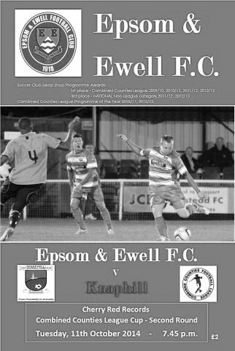
Salts finally get over the 'Hill

Our attempts to reclaim the League Cup from the temporary custody of Hanworth Villa began with the visit of Knaphill. Newly promoted, they were defeated 4-1 by us less than a month ago, so surely everything would be plain sailing, right? The answer to that question was a yes, but there were definitely some choppy waters that we had to navigate before we reached our destination of the last 16 and they were mostly of our own making, due to an inability to convert the numerous chances on offer.

Glyn changed things around a little and we started with a 3-5-2 formation involving the return of Anthony Panayi and the employment of Luke Gaffney and Sean White as wing backs. Panayi and White came in for James Taylor and Matt Tanton who were unavailable, while Matt Robinson started in the absence of Taylor Smith and Matt Ferdinando came in for Dale Marvell, who spent the majority of the evening having a rest on the bench.

It was the perfect team to play this formation against. In our recent win against them we had operated in a different way and it took the opposition some time to deal with the unexpected changes, leading to us having the better of the early exchanges. In fact we could have gone ahead in the first minute when Sam Robinson played a nice reverse pass into the path of his brother Matt, but he dragged his shot beyond the far post. Ferdinando was next to try but his close range effort was blocked close to goal by a defender and out for a corner.

Matt Robinson made a good run down the right but his cross was too high for the incoming players and we received our first warning of what might happen if we didn't take our chances on the ten minute mark. A speculative long shot from the visitors clipped a defender and went out for a corner but we didn't deal with the set piece delivery very well and the ball was fed back in from where a low shot was blocked by Michael Eacott's feet and away.

Hough nearly scored a beauty after 27 minutes when he got on the end of a Matt Robinson cross but volleyed the ball just over the bar. Then Sam Robinson had a shot deflected out for a corner and he then took the kick, only to see his brother's downward header blocked and cleared by a defender on the near post. However, we went ahead in the 29th minute when Sam Robinson collected the ball around 25 yards out and hit an absolute screamer into the top corner. It went straight and true and visiting keeper Richard Shelley did well to even get a finger on it, slightly deflecting the ball onto the inside of the post and into the net.

Eight minutes later it was 2-0 as a clever ball from midfield set Hough up and his low left foot

finish from ten yards was buried into the bottom corner, giving Shelley no chance.

With the opposition restricted to sporadic periods of possession and the occasional long shot, this was surely too much of a lead for them to pull back. However, we gave them a helping hand, literally after 42 minutes when a Knaphill corner was met by a miscued punch from Eacott and the ball fell straight to Nahum Green who drilled the ball in off the legs of our keeper. This led to a nervy few minutes before half time as we struggled to gain a measure of control, although we did have the best chance in those closing stages when Matt Robinson got through but instead chose to cut back and his eventual shot was blocked out for a corner that came to nothing.

The second half started well for us as we raised the tempo and should have had a penalty when Matt Farrell was barged out of the way by a defender with the ball about to drop for him. Frustratingly the referee then gave a foul against us for a far more innocuous contact just after this. It was one of a number of puzzling decisions throughout the match, but especially in the second half.

But to blame the officials would be wide of the mark. The reason this game was so tight was because we couldn't put the opposition away despite numerous chances. The first of which was gifted to us by Shelley, who came out of his area to reach a through ball just ahead of Hough, but then lost the ball and panic ensued for a moment as we tried to make space for a shot with defenders trying to block our every move and eventually the ball was cleared. Another great chance fell to Hough after 52 minutes when Matt Robinson put him through against the keeper. He reached the ball first and rounded Shelley but instead of slotting the ball in from a wide angle as he has regularly done, he appeared to opt for a bit more power and missed the target entirely!

After 61 minutes a Sam Robinson corner was met by a downwards header from George Murphy that the keeper blocked out for a corner. From that set piece Matt Robinson got into a good position but could only get a glancing header when a decent contact would have found the net. He then had another shot deflected for a corner as we began to ramp up the pressure.

However, towards the end, the departure of a limping Hough coupled with the fact that Knaphill were still in the game and only needed the one goal to force extra time, started to give them a bit of belief and Eacott was required to make a good block from an angle after the ball had bounced favourably for the visitors following a defensive challenge after 83 minutes. A minute later Gaffney had to clear off the line as a low shot came in and the possession was certainly more in favour of the visitors for a while. Even then we had another great chance as Matt Robinson was put through with time and just the keeper to beat but just prodded his shot straight at the keeper. Fortunately the whistle went soon after and we were through, but there are no prizes for guessing what would have been the main topic of discussion after the game. Looks like shooting practice on Thursday chaps!

We travel to Frimley Green in the last 16 after they defeated Spelthorne Sports 1-0 after extra time.

Team: Michael Eacott, Sean White, Luke Gaffney, George Murphy, Anthony Panayi ©,
Dan Dean, Matt Farrell, Sam Robinson, Matt Robinson, Kyle Hough, Matt Ferdinando

Subs: Ollie Shaw for Hough (73), Dale Marvell for White (88)

Club Records - 18th October
Date | Day | Competition |  | Opponents |  | Scorers
18/10/24 | Sat | Surrey Senior Cup 2q | A | Camberley & Yorktown | 3-1 | R.Marlow (2), T.Kirk
18/10/30 | Sat | F.A. Cup 2q | A | Mitcham Wanderers | 1-3 | R.Marlow
18/10/47 | Sat | London League | A | Guildford City Res | 0-3
18/10/52 | Sat | Corinthian League | A | Grays Athletic | 2-2 | B.Goddard (2)
18/10/58 | Sat | Corinthian League | A | Worthing | 3-2 | T.Higgins (2), M.Carlson
18/10/69 | Sat | Amateur Cup 1q  third replay | A | Whitehawk | 1-0 | D.Morrish
18/10/75 | Sat | Athenian League 2 | H | Hemel Hempstead F.C. | 1-0 | P.Butler
18/10/80 | Sat | F.A. Cup 3q | H | Ashford Town | 1-0 | F.Samoth
18/10/83 | Tue | Isthmian League 1 | A | Aveley | 1-2 | M.Stratford
18/10/86 | Sat | Isthmian League 1 | H | Basildon United | 0-1
18/10/94 | Tue | Southern Combination Cup Preliminary Round replay | H | Walton & Hersham | 6-0 | S.Smith (2), A.Nimmo (2), C.Hadingham, N.Webb
18/10/97 | Sat | Isthmian League 3 | A | Ford United | 1-6 | M.Owen
18/10/03 | Sat | Isthmian League 1s | A | Staines Town | 0-2
18/10/08 | Sat | Combined Counties Premier Division | A | Sandhurst Town | 4-2 | C.West, K.Hough (3)
Historical Decades
90 years ago – Epsom Town
18/10/24 | Sat | Surrey Senior Cup 2q | A | Camberley & Yorktown | 3-1 | R.Marlow (2), T.Kirk
80 years ago – Epsom F.C.
20/10/34 | Sat | Amateur Cup 2q | H | Tooting & Mitcham United | 3-0 | E.Hannam, M.Wiggins, T.Dunne
70 years ago – War time Epsom Town
21/10/44 | Sat | Friendly | H | Nat Fire Service (Area 38) | 7-2 | S.Tingey (3), G.Brogdale (2), W.Daragon, E.Stone
60 years ago – Epsom F.C.
23/10/54 | Sat | Corinthian League | H | Erith & Belvedere | 1-3 | G.Tillyer
50 years ago – Epsom & Ewell
17/10/64 | Sat | Athenian League Cup 1 | H | Tilbury | 0-3
40 years ago – Epsom & Ewell
19/10/74 | Sat | Surrey Senior Cup 2q | H | Nat West Bank | 9-1 | T.Tuite (4), J.Eales (3), D.Ritman, o.g.
30 years ago – Epsom & Ewell
20/10/84 | Sat | F.A. Trophy 1q | A | Andover | 0-0
20 years ago – Epsom & Ewell
18/10/94 | Tue | Southern Combination Cup Preliminary Round replay | H | Walton & Hersham | 6-0 | S.Smith (2), A.Nimmo (2), C.Hadingham, N.Webb
10 years ago – Epsom & Ewell
16/10/04 | Sat | Isthmian League 2 | H | Chalfont St Peter | 3-0 | M.Owen (2), R.Shoefield

History Corner – 18th October
90 years ago today we made our first ever visit to Krooner Park for a Surrey Senior Cup tie, winning 3-1. Reg Marlow scored twice and Tom Kirk got the other goal. Kirk was sent off in the following round at Egham, although the offence would be rescinded and we won the tie anyway, so it wasn’t all bad! Weybridge surprisingly ended our run in the First Round Proper.

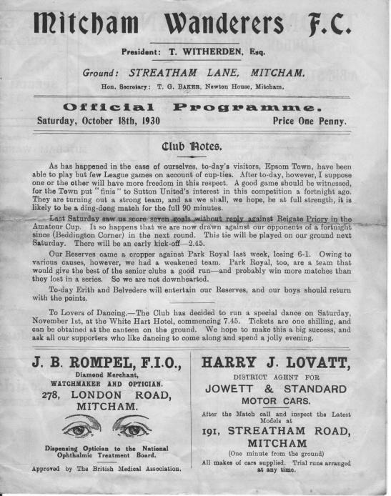
84 years ago today we visited Streatham Lane, home of Mitcham Wanderers for an F.A. Cup tie. (see programme right) We would meet on an incredible seven occasions this season with two further meetings in minor competitions indefinitely postponed, and Mitcham won most of them, including this match, by three goals to one. We would get a measure of revenge in the Amateur Cup, where we would go on to reach the First round for the first of only three times in our history.
70 years ago this week Sid Tingey scored a hat trick for the war time Epsom Town who defeated the National Fire Service (Area 38) in a friendly at West Street. We often had matches against various groups of the Armed Forces to fill out the fixture list and keep people coming to West Street almost every week during those dark times.

45 years ago today the “Whitehawk Quadrilogy” was finally settled in our favour after 420 minutes of play. A Dave Morrish goal finally separated the sides in this third replay, which was Epsom’s second visit to East Brighton Park, a venue that has changed beyond recognition in the last few years.

40 years ago this week there was a bit of a mismatch as we took on the Nat West Bank in the Surrey Senior Cup and destroyed them 9-1 with Dave Ritman missing a penalty that would have made it 10-1. Ironically Manager Pat O’Connell had stopped keeper Chris Page from taking the penalty as he felt it was “taking the mickey” or words to that effect! Page would get his chance later in the season though.

39 years ago today we played a match at home for the first time on this date, with Paul Butler’s goal ensuring a 1-0 Athenian League win over Hemel Hempstead.

34 years ago today we defeated Southern League Ashford Town (the one in Kent) by a goal to nil to reach the fourth and final qualifying round of the F.A. Cup for only the second time in our history. Enfield ended the dreams with a 5-0 win and we’ve only been in the third qualifying round twice since, both of those at least thirty years ago.

30 years ago this week we travelled to the Walled Meadow, Andover’s ground at the time, where we recorded a goalless draw in an F.A. Trophy match. We would win the replay 2-1 while Andover were to lose their ground to housing soon after, leading to a very troubled thirty years for the town.

6 years ago today we recorded a fine 4-2 win at Bottom Meadow against Sandhurst Town, a team we didn’t have the best of records against. Charlie West equalised an early goal for the home side and Kyle Hough then recorded a hat trick as we outclassed our Berkshire opponents.

Ashford Town (Middx) F.C. – History
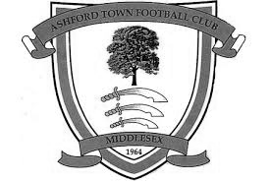
Until recently, it was assumed that Ashford Town Football Club was formed in 1964. However, new research has indicated the club was formed in 1958 as Ashford Albion and first competed in the Hounslow & District League.

Albion won two consecutive promotions to reach the Premier Division of the Hounslow League and were still competing at this level when the club changed its name to Ashford Town in 1964. It was at this time that the club adopted its distinctive Tangerine & White colours. The club endured a difficult first campaign as the Town club and withdrew from the Premier Division, assuming the Reserve Team's place in Division Two.

Having rebuilt the club with a very young team, Ashford Town rapidly advanced through the various divisions of that League, absorbing Staines Youth Club FC on the way. Several individuals from that era have remained with the Club and now form the backbone of the Committee, including the Vice-Chairman and Secretary.

The Club were elected to the Surrey Intermediate League (Western) in 1967 and were promoted at the end of their first season. The Ash Trees were League Cup finalists in 1970-71 and League runners-up in 1972-73. In 1974-75, Ashford enjoyed their best season under the management of ex-Fulham player Frank Reid, winning the League by three points from perennial contenders Merrow.

Although the championship eluded the Club in following seasons, it usually finished in the top four and prior to season 1982-83 an invitation was extended by Surrey County FA. to become founder members of the Surrey County Premier League. The invitation was readily accepted and Ashford played their first match in the new league on 4 September 1982, drawing 0-0 away to Farleigh Rovers.

Almost from its foundation, the Club had aspirations to acquire its own ground and after one or two disappointments, this was achieved in August 1985, when a long lease was signed with Spelthorne Borough Council, enabling the Club to move to its present home at Short Lane, Stanwell. From what was nothing more than a field, the facilities were quickly developed, with the first match at Short Lane taking place in February 1986, following two postponements for snow.

The Club now possesses a modern clubhouse and bar, kitchen facilities and boardroom. Floodlights were erected in September 1995, whilst the pitch is railed all round and partly walled, with standing covered accommodation, plus a purpose built 150-seater stand, built in 1998. An additional 100 seats were installed on the opposite side of the ground to this stand in 2006, after the club won promotion to the Isthmian League Premier Division.

For both geographical and historical reasons, Ashford affiliate to both Middlesex and Surrey F.As and in 1989-90, their last season as an Intermediate Club, they reached the final of both
County Premier Cup competitions, beating Farnham Town in the Surrey version but losing to Willesden Hawkeye in the Middlesex final. Runners-up spot in the League was also secured and with it the opportunity to enter senior football, as members of the Combined Counties League, senior status having been granted in May 1990. It was at this point that the club changed its name
to Ashford Town (Middlesex) FC, to avoid confusion with the Kent club of the same name.

During its ten year membership of the Combined Counties League, the Club never finished below sixth place, and after finishing 3rd and 2nd in seasons 1992-93 and 1993-94, we went on to win the
League Championship for four successive seasons. It was a relative disappointment to only come

4th in 1998-99 even though the Club won the League Cup, but a 5th championship in just six seasons was secured in 99-00, along with the Middlesex Charity Cup, the first ever senior county cup honour. With the ground up to the required standard, Ashford took their place in the Isthmian League for season 2000-2001 and by finishing in 3rd place, secured promotion to Division 2 at the first attempt.

The first season in Division Two did not result in the Club making sufficient progress and after a series of indifferent results, long serving manager Dave Kent left the Club on 28 March. His replacement was Nathan Wharf, a former long serving player, who stepped up from Reserve Team management.

Further major improvements were made to the ground to enable the Club to be granted a B-grade and to take its place in the newly regionalised Division One of the Ryman League. A poor start saw the Club in the bottom echelons of the table but a number of new signings saw a significant improvement and a 17th place finish, which was an excellent performance after winning just one of the opening 16 league matches.

Further progress was made in 2003-04 as the Club finished 12th in Division 1 South. In the close season prior to 2004-05, the pitch has been completely re-laid to include both irrigation and drainage systems, at a cost of around £50,000, mostly financed by the Football Stadia Improvement Fund. Further medium term plans include new changing accommodation adjacent to the pitch, which will allow enlargement of the present clubhouse, and a hard surface floodlit training area.

The Club embarked upon new adventures in season 2004-05 in the Southern League for the first time, having been transferred over as a result of the FA Re-structure. The 4th Qualifying Round of the FA Cup was reached for the first time and Mark Butler, renowned goal scorer in his day with Aldershot Town, Staines Town etc, was promoted from Assistant Manager to Manager following the resignation of Nathan Wharf in December 2004. The play-offs were reached but resulted in a narrow defeat at Evesham United after extra time.

In 2005-06, Ashford went one better, finishing second in Division One West of the Southern League, to secure promotion to Step 3. This brought about a return to the Isthmian League for season 2006-07 and saw Ashford competing at their highest ever level. The season brought consolidation with the added bonus of reaching and winning the Westview (League) Cup Final when Ashford triumphed 4-1 over Dover Athletic at Bromley. The Reserves also lifted a trophy, securing the Middlesex Premier Cup.

Ashford built on this success, rallying from the foot of the table in November 2007 to narrowly miss a place in the promotion play-offs at the end of the 2007-08 season, a campaign which saw all of the club's senior sides challenge for honours. The senior side reached the Final of the Southern Combination Cup, the Reserves reached the Finals of both the Middlesex Premier and Surrey Premier Cups, while the Under 18s, led by club stalwart, Mick Snowden were champions of the Southern Youth League.

The 2008-09 season saw Ashford begin the campaign in electrifying form, winning their opening six matches to top the table. Mark Butler's side followed this up with a fantastic FA Cup run which saw them come agonisingly close to eliminating Forest Green Rovers in the Fourth Qualifying Round at Short Lane. Rovers won the replay and went on to run Derby County close in the Third Round.

Ashford endured a difficult winter, which saw them flirt with relegation, before a late resurgence saw the side safely into mid-table. The cup competitions added much adventure to the season, as Ashford followed up their exploits in the F.A. Cup with runs to the semi-finals of both the Middlesex Senior and Isthmian League Cups and ended their campaign by defeating Conference Premier outfit

Woking 3-2 at Metropolitan Police to win the Surrey Senior Cup.

The 2009-10 season saw Ashford make a reasonable start to the campaign, but the Ash Trees were shocked when manager Mark Butler tendered his resignation on Friday 23rd October, in order to take up the Manager's role at Margate FC, who were struggling at the foot of the table. Ashford appointed former Leicester City and Bradford City midfielder Jamie Lawrence as his replacement, and the Jamaican international immediately led his new charges on a twelve-match unbeaten run. However, issues off the pitch were causing problems for the club and a number of players, including leading goalscorer Byron Harrison left for Carshalton Athletic, where Mark Butler had accepted a coaching role after leaving Margate, where he had been in charge for just three months.

Ashford found scoring a problem after Harrison left and a dreadful run of form saw them go from the fringe of the play-off zone to battling relegation. Ashford went into their final match knowing a win would almost guarantee survival, while a draw would see them finish fourth from bottom - technically a relegation place, but certain to receive a reprieve owing to the demise of various other clubs. Sadly, a heavy defeat for Ashford, coupled with wins for Carshalton and Margate saw the latter two clubs survive - Margate receiving the reprieve for finishing fourth from bottom.

During the summer of 2010, the club were initially placed in the Central Division of the Southern League but were then offered the chance to remain at Step Three of the non-league pyramid. However, as this offer was as a direct replacement for defunct Southern League side Merthyr Tydfil, the decision was made that the vast increase in travelling would be too great a burden for the club and the club elected to remain in the Central Division.

During this time, Bob Parker stepped down from his role as Chairman after twenty-eight years in the role. The club's home ground was renamed the Robert Parker Stadium in honour of Bob, who remains at the club as President.

The club entered a new era in the Central Division of the Southern League with Jamie Lawrence at the helm and with a mixture of established local players and new faces but the season was a challenging one. The club played some sparkling football at times and enjoyed an exciting run in the FA Trophy, reaching the Last 32 in the competition before losing at home to Dartford. However, League form was patchy and the club finished 16th. One bright spark was the club winning the Southern Combination Cup, defeating Hanworth Villa 1-0 in the Final.

Jamie Lawrence resigned as Manager in June 2011 and the club immediately appointed his assistant, Paul Burgess, to take the helm after more than 21 years at the club, including 683 First Team appearances. Despite having little time to do it and few resources at his disposal, "Burgo" assembled a young and exciting team.

Although any hopes of a tilt at the promotion play-offs were dashed by a dreadful run where the club failed to win at home for four months, Ashford finished the season strongly, winning two Cup Finals in 48 hours. In the Middlesex Charity Cup Final, the Ash Trees were 3-0 down to Northwood after 48 minutes before substitute Kofi Lockhart-Adams scored four times to put his team ahead. The game finished 4-4, with Ashford winning the penalty shoot-out 4-2.

Two days later, Ashford defeated Badshot Lea 3-1 to add the Aldershot Senior Cup to the cabinet, aided by a fine performance from Paul McCarthy, who had saved two penalties in the first Final. A memorable season was capped by the club being named winners of the Southern League Fair Play Award.

Season 2013/14 was not so successful, as we finished at the bottom of the Southern League Central, dropping back to the Combined Counties League for 2014/15.

EL Records Premier Challenge Cup
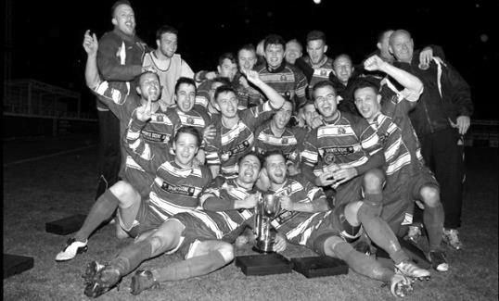
Second Round
Alton Town | V | Farnham Town
Ashford Town (Mx) | 5-0 | CB Hounslow United
Badshot Lea | 10-2 | Dorking
Bedfont Sports | 1-1+ | Cove
Cove won 4-1 on penalties
Camberley Town | 0-0+ | Molesey
Camberley Town won 3-0 on penalties
Chertsey Town | 0-7 | Windsor
Cobham | V | Horley Town
Colliers Wood United | 3-0 | Bedfont & Feltham
Epsom & Ewell | 2-1 | Knaphill
Epsom Athletic | V | Banstead Athletic
Eversley & California | 21/10 | Ash United
Frimley Green | 1-0+ | Spelthorne Sports
Hanworth Villa | V | Guildford City
Sheerwater | 1-6 | Mole Valley SCR
Westfield | V | Farleigh Rovers
Worcester Park | 29/11 | Chessington & Hook United
Third Round
Westfield / Farleigh Rovers | V | Cove
Badshot Lea | V | Hanworth Villa / Guildford City
Worcester Park / Chessington & Hook | V | Epsom Athletic / Banstead Athletic
Alton Town / Farnham Town | V | Mole Valley SCR
Frimley Green | V | Epsom & Ewell
Windsor | V | Eversley & California / Ash United
Colliers Wood United | V | Cobham / Horley Town
Camberley Town | V | Ashford Town (Mx)
Centre page for results

Centre page for results

Match and Ball Sponsorships – 2014/15
Opponent | Date | Match Sponsor | Ball Sponsor
Raynes Park Vale | 05/08/14 | Club President - Stella Lamont
Horley Town | 25/08/14 | Epsom & Ewell F.C. Management Committee
Croydon (FAC) | 30/08/14 | Media Officer - Richard Lambert
Frimley Green | 13/09/14 | Dave Gaffney and friends
Guildford City | 30/09/14 | The Jarman family
Mole Valley SCR | 07/10/14 | Mark and Carmel Murphy
Bedfont Sports | 11/10/14 | Epsom & Ewell F.C. Colts
Knaphill (LC) | 14/10/14 | Geoff and Steve Dyke
Ashford Town (Mx) | 18/10/14 | The Building Shop, Bookham
Chertsey Town | 28/10/14
Molesey | 22/11/14 | Provisional and dependent on any Vase progress
Camberley Town (SSC) | 02/12/14 | Provisional date
Hanworth Villa | 06/12/14
Windsor | 03/01/15
Farnham Town | 17/01/15
Westfield | 31/01/15
Camberley Town | 07/02/15
Hartley Wintney | 21/02/15
Cove | 07/03/15
Badshot Lea | 21/03/15
Colliers Wood United | 04/04/15
Knaphill | 18/04/15
Spelthorne Sports | tba
For League, League Cup and Surrey Senior Cup Matches:

Match sponsorship - £40.00 Match ball sponsorship - £25.00.
Combined Offer of Match and Match Ball sponsorship for £55.00.

For F.A. Cup and F.A. Vase matches:

Match sponsorship - £50.00 Match ball sponsorship - £30.00.
Combined Offer of Match and Match Ball sponsorship for £65.00.
----------------------------------------------------------------------------------------------------------------------------
Sponsorship includes

Admission, programmes, advertising (if required) and hospitality.

If you are interested, just speak to a Committee Member, you know where we are!
Alternatively, drop me an email at: richard.c.lambert@gmail.com

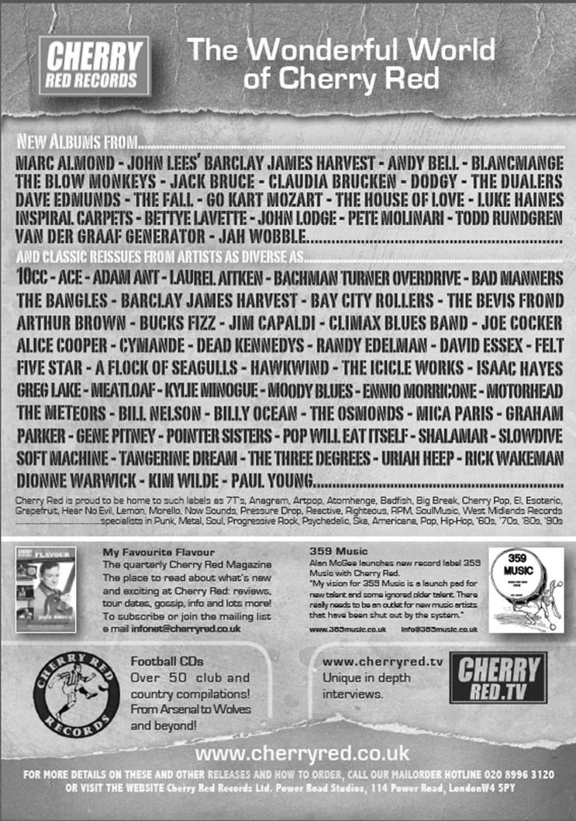
Player Sponsorship
Here is the latest list showing all of the players and Management available for sponsorship. Sponsorship costs £40 so if you want to help the club, the player and get your name in the programme for the season, just let us know.

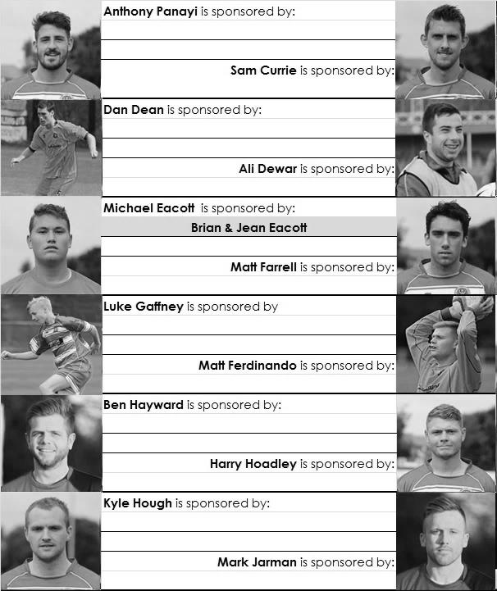

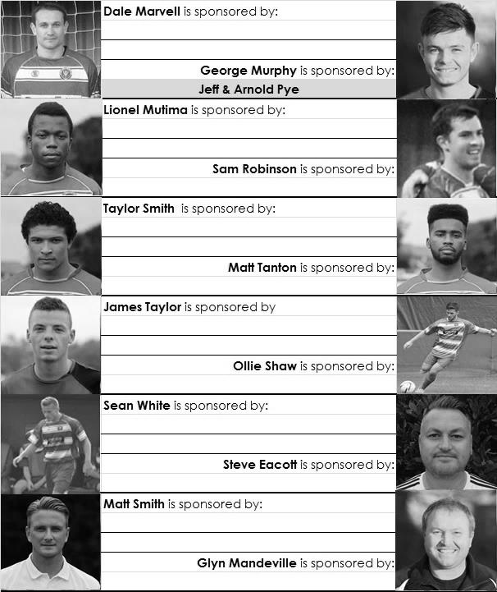

We are not fussy; we’ll take cash or a cheque! Any donation will help the club and is much appreciated.

Every Opponent A-Z
Over the years we have played many, many different opponents. Exactly how many is a difficult question, as it all depends on your definition. Are Camberley & Yorktown different to Camberley Town, or are Epsom Town different to Epsom F.C. or Epsom & Ewell F.C.?

In my analysis I have classed them as the same team, and will work through them all from A to Z. Some we have played many times, whilst others we have met maybe just once or twice. Enjoy!

Maidenhead United: Played 55 - W22 D8 L25 - F89 A97 - PPG - 1.35 - Average

Maidenhead United have advanced to a higher level these days, playing as members of the Conference South. However, back in the day we were regular opponents.

The first time Maidenhead appeared on the Epsom radar it was our wartime Epsom Town who faced them with both as founder members of the Corinthian League in 1945/46. The first match on 22nd December 1945 was a blowout with the Magpies winning 7-4 in a League Cup tie, although both home sides won in the League by a goal to nil. In fact, the loss at Maidenhead on 4th May 1946 was to be Epsom Town’s final game before folding; their job of building and maintaining morale in the town during the dark days of the war being complete.

In 1949 Epsom F.C. joined the Corinthian League and we met Maidenhead United frequently over the next fourteen years before the League merged with the Athenian League in 1963 and they were moved up to the top division.

Our first League meeting came at York Road, one of the oldest football grounds in the World, although I doubt our players would have been that interested in the history as they were beaten 6-2. We drew the return match and even won our next game in the following season by three goals to two at West Street but lost away from home.

We were having an awful sequence of away results, not winning for two and a half years since joining the Corinthian League, but our first away win actually came there on 26th January 1952 when we won 2-1 with goals from Tommy Rochester and Johnny Hoy.

We were in good form by that stage and thrashed them 8-1 the following month in the Semi-Final of the Corinthian League Memorial Shield (League Cup), only to lose to Hounslow in the Final. We completed a League double the following season but they returned the favour in 1953/54, before the following season’s games were shared 2-2!

The 1955/56 season was a mixed bag. We lost two home games, one in the Memorial Shield but won the away trip by five goals to one! The next season we shared the League fixtures although the big match that year was at Meadowbank, home of Dorking F.C. where the Final of the Memorial Shield took place between the two teams. Unfortunately star striker Johnny Bangs was injured early in the match and we lost 2-0.

We relieved them of their trophy with a 5-0 second round win the following February but as with the season before and the two after that, the home sides won their respective League matches.

In 1959/60, there was another big match between the two when we gained revenge with a 2-0 win over the Magpies in the Memorial Shield Final at Wembley F.C. Steve Dunwoody, brother of our late long-serving supporter Danny, scored twice while on leave from National service. It would be the last trophy we would win until 1974.

The sixties were a lean time for us and we only won one and drew one of our final six League encounters. We then had a break of fifteen years before we met in the Isthmian League Division One. Results were unremarkable with exception of a couple of heavy away wins for us; 5-2 on 30th April 1981 and 4-1 on 5th December, my first visit there. On both occasions Tommy Tuite scored hat tricks.

We defeated them 2-1 at West Street on our way to the Isthmian League Premier Division, but we were back down in Division One for 1986/87 and facing a relegation battle along with Maidenhead. Ultimately we both went down that season as both teams won their home matches 1-0. The next season it was a different division, but same old results as the home sides won out again.

In 1988/89 we drew 1-1 at home but managed a 1-0 win in the return on 15th April. That win would be our last ever at York Road and was also easy to remember as it was the day of the Hillsborough disaster and a few of us heard the events unfolding behind the lower goal on much missed supporter Chris Henry’s radio!

We lost our remaining three matches against them; our final meeting being an 0-4 defeat at York Road on 19th January 1991 and at the end of the season we went into the Isthmian League Division Three and they went up to Division One as runners up to Abingdon Town.

We have returned there on one further occasion when we borrowed their ground for a home match against Aveley on 3rd February 1996 and witnessed one of the classic own goals from an Aveley player, although had to settle for a 2-2 draw in the end!

The Magpies remain a consistent performer at their new level and have just unveiled a new grandstand to replace their ornate wooden stand that burned down nearly thirty years ago, albeit on the other side of the ground. Here is a picture of the old one.

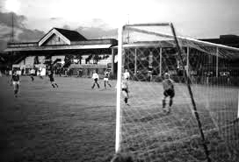

F.A. Vase
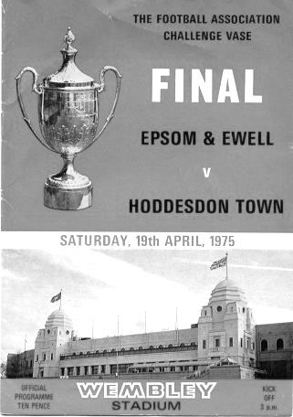
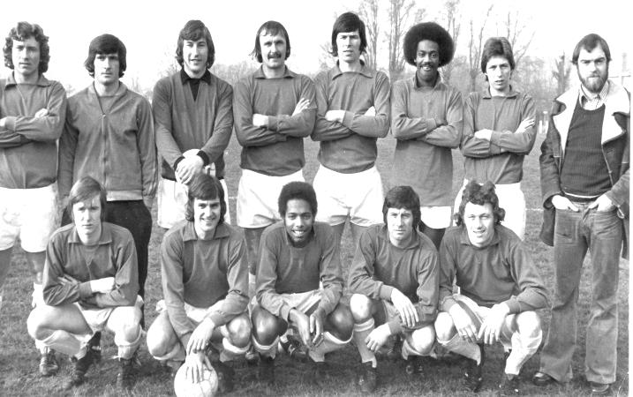
Second Qualifying Round – 4th October
Colliers Wood United | 2-1 | Shoreham
Cray Valley (PM) | 0-2 | Horley Town
Farnham Town | 2-1 | Milton United
Flackwell Heath | 5-0 | Frimley Green
Highworth Town | 2-1+ | Hartley Wintney
Spelthorne Sports | 2-1 | Risborough Rangers
Molesey | 1-2 | Greenwich Borough
Raynes Park Vale | 2-1 | Epsom Athletic
Rothwell Corinthians | 0-1 | Bedfont Sports
Windsor | 4-0 | Binfield
Woodley Town | 0-2 | Knaphill
First Round Proper – 1st November
Ashford Town (Mx) | V | Loxwood
Chertsey Town | V | Horley Town
Chessington & Hook United | V | Camberley Town
Colliers Wood United | V | Ringmer
Farnham Town | V | Abingdon United
Horsham YMCA | V | Bedfont Sports
Lingfield | V | Epsom & Ewell
Littlehampton Town | V | Guildford City
Lordswood | V | Knaphill
Pagham | V | Spelthorne Sports
Raynes Park Vale | V | Westfield
Windsor | V | Highworth Town
Hanworth Villa are exempted to the Second Round

Surrey Senior Cup
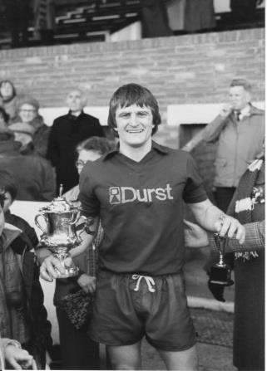

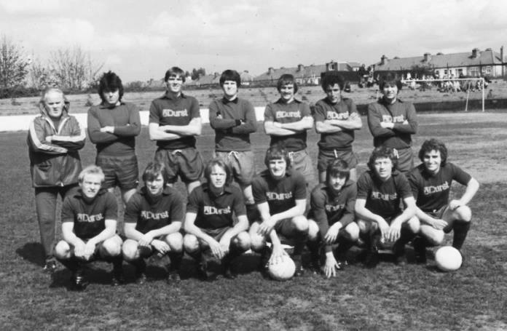
First Round
Carshalton Athletic | 21/10 | Egham Town
Croydon | 22/10 | Colliers Wood United
Merstham | 21/10 | Whyteleafe
Raynes Park Vale | 21/10 | Chertsey Town
South Park | 21/10 | Guildford City
Second Round
Lingfield | V | Westfield
Redhill | V | Raynes Park Vale /  Chertsey Town
AFC Wimbledon | V | Chipstead
Godalming Town | 11/11 | Mole Valley SCR
Knaphill | V | Croydon /  Colliers Wood United
Metropolitan Police | V | Walton & Hersham
Epsom & Ewell | V | Camberley Town
Leatherhead | 26/11 | Farnham Town
Merstham / Whyteleafe | V | Beckenham Town
Molesey | V | Carshalton Athletic /  Egham Town
South Park / Guildford City | V | Sutton United
Walton Casuals | 25/11 | Corinthian Casuals
Badshot Lea | V | Kingstonian
Dorking Wanderers | V | Frimley Green
Tooting & Mitcham United | V | Horley Town
Woking | V | Ashford Town (Mx)

Club Directory
ASHFORD TOWN (Mx) Telephone: 01784-245908 - Ground: The Robert Parker Stadium, Short Lane, Stanwell. TW19 7BH - Colours: Tangerine & White Stripes/Black/Tangerine

BADSHOT LEA Telephone: 01252-320385 - Ground: Ash United FC, Shawfield Stadium, Youngs Drive, Shawfields Road, Ash, Hampshire. GU12 6RE - Colours: Claret/White/Claret

BEDFONT SPORTS Telephone: 0208-831-9067 - Ground: Bedfont Sports Club, Hatton Road, Bedfont, Middx TW14 8JA - Colours: Red & Black Hoops/Black/Red & Black Hoops

CAMBERLEY TOWN Telephone: 01276-65392 - Ground: Krooner Park, Wilton Road, Camberley, Surrey. GU15 2QW - Colours: Red & White Stripes/Blue/Red

CHERTSEY TOWN Telephone: 01932-561774 - Ground: Alwyns Lane, Chertsey, Surrey. KT16 9DW - Colours: Royal Blue & White Stripes/Royal Blue/Royal Blue

COLLIERS WOOD UNITED Telephone: 0208-942 8062 - Ground: Wibbandune Sports Ground, Lincoln Green, Opposite 199-213, Robin Hood Way, Wimbledon. SW20 0AA - Colours: Blue & Black Stripes/Black/Black

COVE Telephone: 01252-543615 - Ground: Oak Farm Fields, 7 Squirrel Lane, Cove, Farnborough, Hampshire. GU14 8PB - Colours: Yellow/Black/Yellow

EPSOM & EWELL Telephone: 01737-553250 - Ground: Chipstead FC, High Road, Chipstead, Surrey. CR5 3SF - Colours: Royal Blue & White Hoops/Royal Blue/Royal Blue & White Hoops

FARNHAM TOWN Telephone: 01252-715305 Ground: Memorial Ground, Babbs Mead, West Street, Farnham, Surrey. GU9 7DY Colours: - Claret & Sky Blue /White/ Claret & Sky Blue

FRIMLEY GREEN Telephone: 01252-835089 - Ground: Frimley Green Recreation Ground, Frimley Green Road, Frimley Green, Camberley, Surrey. GU16 6JY - Colours: Blue & White/Blue/Blue

GUILDFORD CITY Telephone: 01483-443322 - Ground: The Spectrum, Parkway, Guildford, Surrey. GU1 1UP - Colours: Red & White Stripes/Black/Black

HANWORTH VILLA Telephone: 0208-831-9391 - Ground: Rectory Meadows, Park Road, off Hounslow Road, Hanworth, Middlesex. TW13 6PN - Colours: Red & White Stripes/Black/Black

HARTLEY WINTNEY Telephone: 01252-843586 - Ground: Memorial Playing Fields, Green Lane, Hartley Wintney, Hants RG27 8DL - Colours: Orange & Black/ Orange /Orange

HORLEY TOWN Telephone: 01293-822000 - Ground: The New Defence, Anderson Way, Court Lodge Road, Horley, Surrey. RH6 8SP - Colours: Claret & Sky Blue/Claret/Claret

KNAPHILL Telephone: 01483-475150 - Ground: Brookwood Country Park, Redding Way, Lower Guildford Road, Knaphill, Surrey. GU21 2AY - Colours: Red/Black/Red

MOLE VALLEY SCR Telephone: 01932-866386 - Ground: Cobham FC, Leg O’Mutton Field, Anvil Lane, Downside Bridge Road, Cobham, Surrey KT11 1AA - Colours: Yellow/Black/Black

MOLESEY Telephone: 0208-979-4283 - Ground: 412 Walton Road, West Molesey, Surrey KT8 2JG - Colours: White/Black/Black

RAYNES PARK VALE Telephone: 020-8540-8843 - Ground: Prince Georges Playing Field, Grand Drive, Raynes Park, London. SW20 9NB - Colours: Blue/Blue/Red

SPELTHORNE SPORTS Telephone: 01932-961055 - Ground: Spelthorne Sports Club, 296 Staines Road, Ashford Common, Ashford, Middx. TW15 1RY - Colours: Light & Dark Blue/Dark Blue/Light Blue

WESTFIELD Telephone: 01483-771106 - Ground: Woking Park, Kingfield Road, Woking, Surrey. GU22 9BA - Colours: Yellow/Black/Black

WINDSOR Telephone: 01753-860656 - Ground: Stag Meadow, St Leonards Road, Windsor, Berks SL4 3DR - Colours: Red/Red/Red

Our New Website
Have you seen our website?

For those who are unaware, our website, now over a year old, contains everything you could possibly want to know about the club and an enormous amount you may not have been aware of!

Our previous site will still exist, as a photo archive only, housing the enormous wealth of pictures provided by Gemma Jarman, our Club photographer. In addition, there are over a thousand historical images of teams, players, action shots and programme covers.

As you can tell from the screenshot of our front page, there is a substantial amount of information all available at the touch of a button, which is also very useful if you own one of those new touchscreen personal computers that are becoming more and more popular these days.

If you are a supporter, please pass the address on to anyone you know that has ever expressed an interest in the club, especially those who don’t visit any more. You never know, some of them might be inspired to come along too, and bring their friends etc.

http://www.eefconline.co.uk/

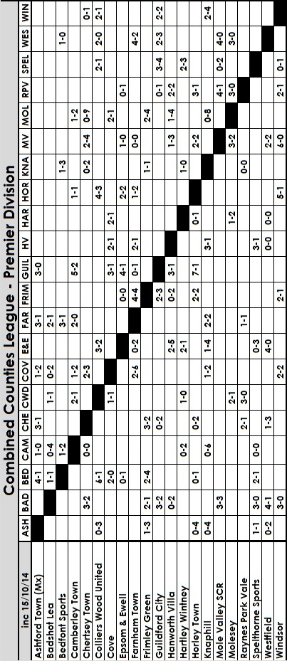

Scouting the Opponent – Lingfield F.C.
With my supporter’s hat on, the F.A. draws have been kind to us. In the Cup we were sent to Hassocks for the first time and now in the Vase our First team make their inaugural visit to Lingfield.

Lingfield have been around for years, being formed back in 1893 and although entering the Surrey Senior Cup in years past, have spent much of their recent history as members of the Sussex League. As of this season though it was pastures new as they were transferred along with Croydon from our League into the Southern Counties East League, the not very user-friendly name of the former Kent League.

Situated just over a mile away, as the crow flies, from the Lingfield Park race course, the Lingers have shared with the local cricket ground for a while now. The venue is not completely unknown to our club as our Reserves went there twice in Suburban League competition in 2010/11 and 2011/12, winning 4-2 and then losing 0-9 when admittedly we played with nine men throughout!

They currently have the worst defensive record and the worst goal difference in the division, but they have scored as many as the second placed team, so there should be goals when we meet!
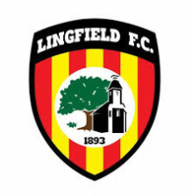
The main stand at the Pavilion; home to Lingfield F.C.

Southern Counties East League Table
inc Saturday 11th October | P | W | D | L | F | A | Pts | GD
Erith & Belvedere | 13 | 11 | 1 | 1 | 42 | 12 | 34 | 30
Ashford United | 13 | 7 | 5 | 1 | 27 | 13 | 26 | 14
Phoenix Sports | 10 | 7 | 3 | 0 | 22 | 5 | 24 | 17
Tunbridge Wells | 14 | 7 | 3 | 4 | 22 | 16 | 24 | 6
Lordswood | 13 | 6 | 3 | 4 | 17 | 20 | 21 | -3
Beckenham Town | 11 | 6 | 2 | 3 | 25 | 16 | 20 | 9
Sevenoaks Town | 11 | 6 | 2 | 3 | 19 | 16 | 20 | 3
Canterbury City | 12 | 6 | 2 | 4 | 19 | 18 | 20 | 1
Corinthian | 10 | 6 | 0 | 4 | 25 | 16 | 18 | 9
Holmesdale | 11 | 4 | 2 | 5 | 24 | 19 | 14 | 5
Woodstock Sports | 12 | 4 | 2 | 6 | 16 | 21 | 14 | -5
Greenwich Borough | 7 | 4 | 1 | 2 | 13 | 10 | 13 | 3
Cray Valley (PM) | 13 | 3 | 3 | 7 | 31 | 32 | 12 | -1
Crowborough Athletic | 12 | 4 | 0 | 8 | 24 | 32 | 12 | -8
Lingfield | 12 | 4 | 0 | 8 | 27 | 44 | 12 | -17
Croydon | 11 | 3 | 2 | 6 | 13 | 19 | 11 | -6
Fisher | 11 | 3 | 2 | 6 | 13 | 29 | 11 | -16
Erith Town | 14 | 2 | 3 | 9 | 16 | 28 | 9 | -12
Deal Town | 11 | 2 | 2 | 7 | 8 | 21 | 8 | -13
Rochester United | 13 | 2 | 2 | 9 | 21 | 37 | 8 | -16

Combined Counties League – Premier Division
Saturday, 18th October 2014 - Kick-off 3.00 p.m.
Epsom and Ewell  (Royal Blue & White hoops) | V |  | Ashford Town  (Tangerine and White)
 | NUMBERS
Michael Eacott |  |  | Tyler Tobin
James Taylor |  |  | Joe Green
Luke Gaffney |  |  | Alex Fisher
© George Murphy |  |  | Rob Curtis
Dan Dean |  |  | Russell Canderton
Matt Tanton |  |  | Max Webb
Sam Robinson |  |  | Jack Mullan
Matt Farrell |  |  | Mark Bitmead
Taylor Smith |  |  | Dan Fleming
Kyle Hough |  |  | Tom Brunton
Dale Marvell |  |  | Conor Moody
Matt Robinson |  |  | Ryan Dearden
Lionel Mutima |  |  | Samad Kazi
Matt Ferdinando |  |  | Kieran Wright
Ollie Shaw |  |  | Joe Hughes
Anthony Panayi |  |  | Jack Beadle
Ben Hayward
Ali Dewar
Mark Jarman
Sean White
Glyn Mandeville | MANAGER |  | Ben Murray
Matt Smith | ASSISTANT |  | Mark Green
Steve Eacott / Alex McKay | COACHES
Ken Jones | PHYSIO |  | Pat Munns
REFEREE: M.Smith (West Drayton)
ASSISTANTS: M.Stevens (Morden), S.Aina (West Drayton)
Today’s Match and Match Ball are sponsored by
The Building Shop, Bookham

OUR NEXT VISITORS TO HIGH ROAD
Chertsey Town
Tuesday 28th October 2014 - Kick-off 7.45 p.m.
Combined Counties League – Premier Division

